FOCP C Programming Assignment
Module 3: Loops
Question 5: Sum of Multiples
Platform: LeetCode
Programming Language: C
Problem Link: https://leetcode.com/problems/sum-multiples
Problem Statement
Given a positive integer n, find the sum of all integers in the range [1, n] (inclusive) that are divisible by 3, 5, or 7.
Return an integer representing the sum of all numbers satisfying this condition.
Examples
Example 1:
Input: n = 7
Output: 21
Explanation: The numbers divisible by 3, 5, or 7 are 3, 5, 6, and 7. Their sum is 21.
Example 2:
Input: n = 10
Output: 40
Explanation: The numbers divisible by 3, 5, or 7 are 3, 5, 6, 7, 9, and 10. Their sum is 40.
Example 3:
Input: n = 9
Output: 30
Explanation: The numbers divisible by 3, 5, or 7 are 3, 5, 6, 7, and 9. Their sum is 30.
Constraints
- 1 <= n <= 10^3
Source Code
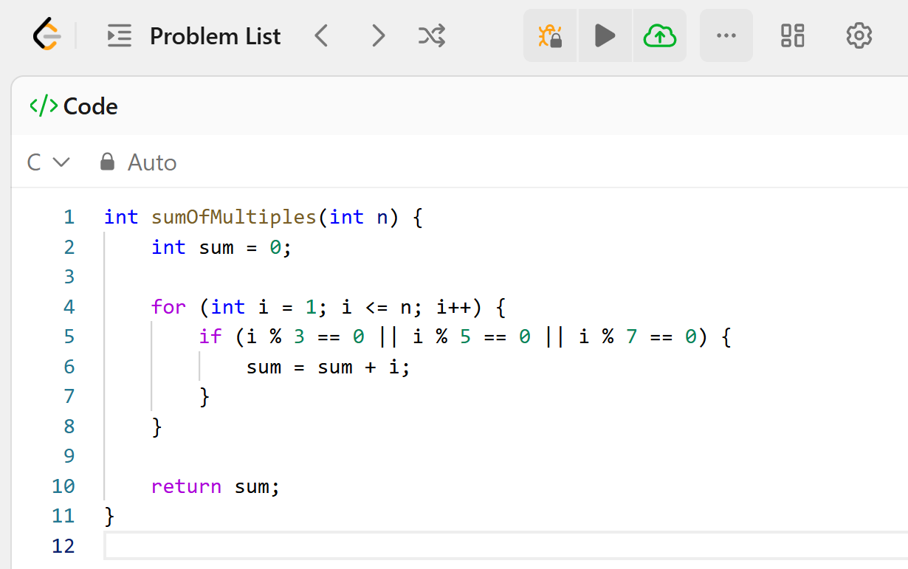Output
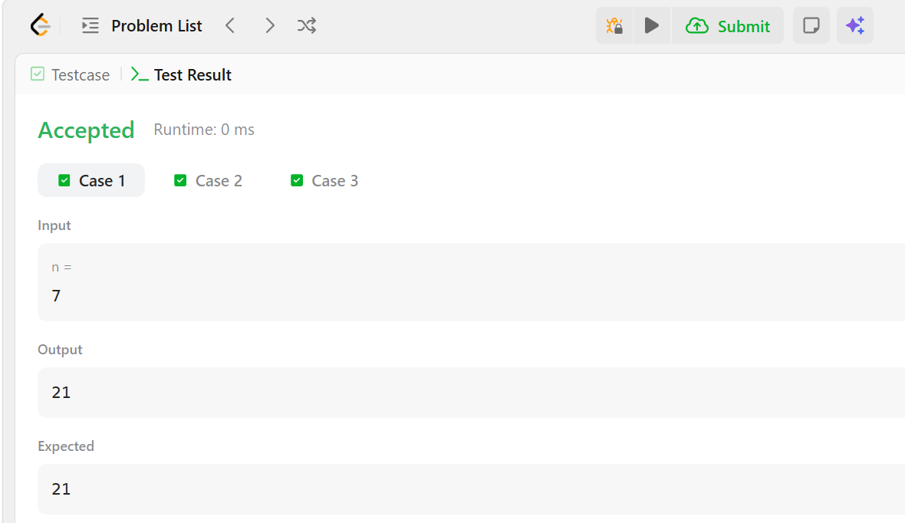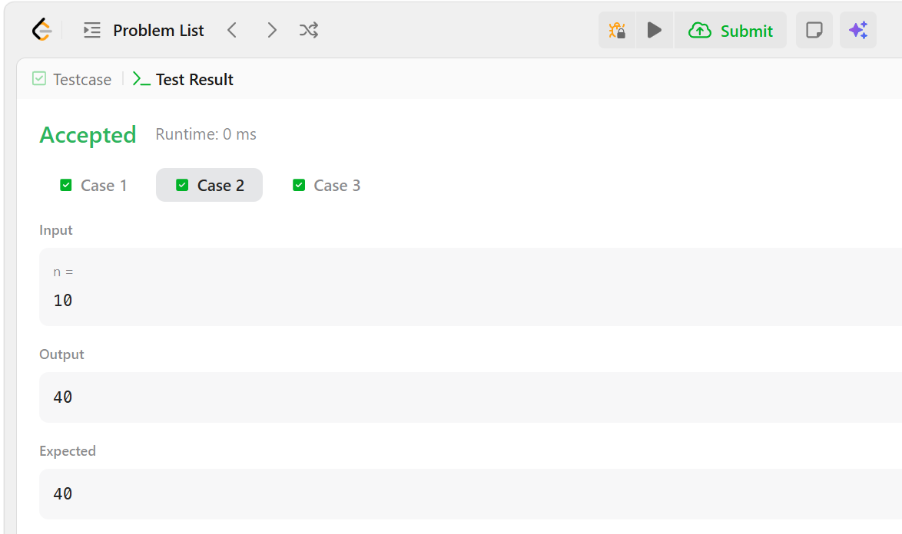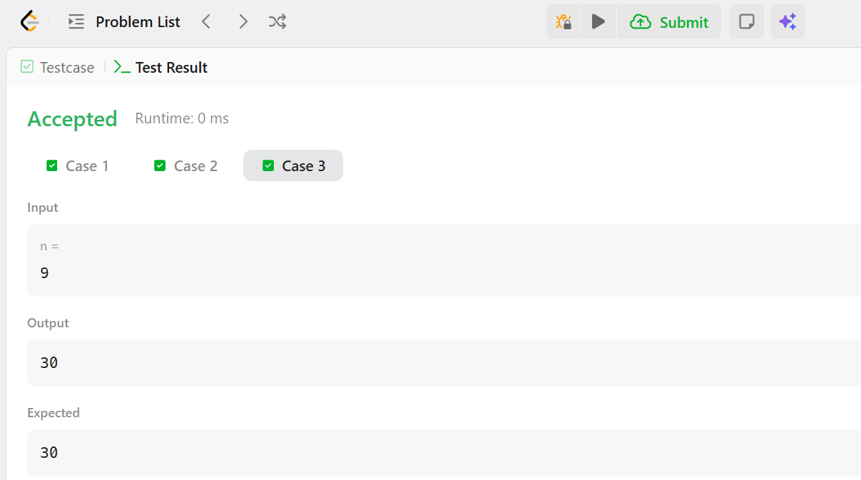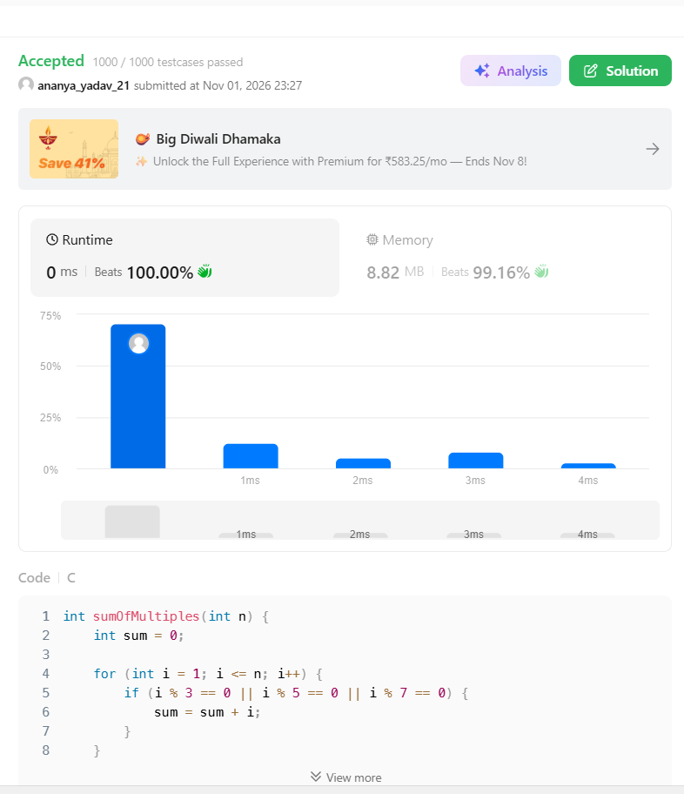Result
The program was executed successfully, and all test cases were passed on LeetCode.

